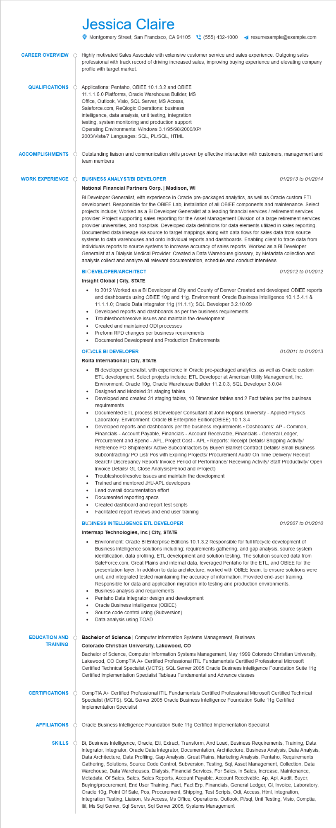
CAREER OVERVIEW
QUALIFICATIONS
ACCOMPLISHMENTS
Jessica Claire
Montgomery Street, San Francisco, CA 94105(555) 432-1000 ◄ resumesample@example.com
Highly motivated Sales Associate with extensive customer service and sales experience. Outgoing sales professional with track record of driving increased sales, improving buying experience and elevating company profile with target market.
Applications: Pentaho, OBIEE 10.1.3.2 and OBIEE 11.1.1.6.0 Platforms, Oracle Warehouse Builder, MS Office, Outlook, Visio, SQL Server, MS Access, Saleforce.com, ReQlogic Operations: business intelligence, data analysis, unit testing, integration testing, system monitoring and production support Operating Environments: Windows 3.1/95/98/2000/XP/ 2003/Vista/7 Languages: SQL, PL/SQL, HTML
Outstanding liaison and communication skills proven by effective interaction with customers, management and team members
WORK EXPERIENCE
BUSINESS ANALYST/BI DEVELOPER
National Financial Partners Corp. | Madison, WI
01/2013 to 01/2014
BI Developer Generalist, with experience in Oracle pre-packaged analytics, as well as Oracle custom ETL development. Responsible for the OBIEE Lab, installation of all OBIEE components and maintenance. Select projects include; Worked as a BI Developer Generalist at a leading financial services / retirement services provider. Project supporting sales reporting for the Asset Management Division of a large retirement services provider universities, and hospitals. Developed data definitions for data elements utilized in sales reporting. Documented data lineage via source to target mappings along with data flows for sales data from source systems to data warehouses and onto individual reports and dashboards. Enabling client to trace data from individuals reports to source systems to increase accuracy of sales reports. Worked as a BI Developer Generalist at a Dialysis Medical Provider. Created a Data Warehouse glossary, by Metadata collection and analysis collect and analyze all relevant documentation, schedule and conduct interviews.
BIOEVELOPER/ARCHITECT
Insight Global | City, STATE
•
01/2012 to 01/2012
to 2012 Worked as a BI Developer at City and County of Denver Created and developed OBIEE reports and dashboards using OBIEE 10g and 11g. Environment: Oracle Business Intelligence 10.1.3.4.1 & 11.1.1.0; Oracle Data Integrator 11g (11.1.1); SQL Developer 3.2.10.09
Developed reports and dashboards as per the business requirements
Troubleshoot/resolve issues and maintain the development
Created and maintained ODI processes
•
Preform RPD changes per business requirements
·
Documented Development and Production Environments
OFACLE BI DEVELOPER
Rolta International | City, STATE
•
•
01/2011 to 01/2013
BI developer generalist, with experience in Oracle pre-packaged analytics, as well as Oracle custom ETL development. Select projects include: ETL Developer at American Utility Management, Inc. Environment: Oracle 10g, Oracle Warehouse Builder 11.2.0.3; SQL Developer 3.0.04
Designed and Modeled 31 staging tables
Developed and created 31 staging tables, 10 Dimension tables and 2 Fact tables per the business requirements
Documented ETL process BI Developer Consultant at John Hopkins University - Applied Physics Laboratory. Environment: Oracle BI Enterprise Edition (OBIEE) 10.1.3.4
Developed reports and dashboards per the business requirements Dashboards: AP - Common, Financials - Account Payable, Financials - Account Receivable, Financials - General Ledger, Procurement and Spend - APL, Project Cost - APL = Reports: Receipt Details/ Shipping Activity/ Reference PO Shipments/ Active Subcontractors by Buyer/ Blanket Contract Details/ Small Business Subcontracting/ PO List/ Pos with Expiring Projects/ Procurement Audit/ On Time Delivery/ Receipt Search/ Discrepancy Report/ Invoice Period of Performance/ Receiving Activity/Staff Productivity/Open Invoice Details/ GL Close Analysis (Period and /Project)
Troubleshoot/resolve issues and maintain the development
Trained and mentored JHU-APL developers
Lead overall documentation effort
Documented reporting specs
•
Created dashboard and report test scripts
Facilitated report reviews and end user training
BLOINESS INTELLIGENCE ETL DEVELOPER Intermap Technologies, Inc | City, STATE
01/2007 to 01/2010
• Environment: Oracle BI Enterprise Editions 10.1.3.2 Responsible for full lifecycle development of Business Intelligence solutions including; requirements gathering, and gap analysis, source system identification, data profiling, ETL development and solution testing. The solution sourced data from SaleForce.com, Great Plains and internal data, leveraged Pentaho for the ETL, and OBIEE for the presentation layer. In addition to data architecture, worked with OBIEE team, to ensure solutions were unit, and integrated tested maintaining the accuracy of information. Provided end-user training. Responsible for data and application migration into testing and production environments. Business analysis and requirements
•
Pentaho Data Integrator design and development
•
Oracle Business Intelligence (OBIEE)
Source code control using (Subversion)
•
Data analysis using TOAD
EDUCATION AND TRAINING
CERTIFICATIONS
Bachelor of Science | Computer Information Systems Management, Business Colorado Christian University, Lakewood, CO
Bachelor of Science, Computer Information Systems Management, May 1999 Colorado Christian University, Lakewood, CO CompTIA A+ Certified Professional ITIL Fundamentals Certified Professional Microsoft Certified Technical Specialist (MCTS): SQL Server 2005 Oracle Business Intelligence Foundation Suite 11g Certified Implementation Specialist Tableau Fundamental and Advance classes
CompTIA A+ Certified Professional ITIL Fundamentals Certified Professional Microsoft Certified Technical Specialist (MCTS): SQL Server 2005 Oracle Business Intelligence Foundation Suite 11g Certified Implementation Specialist
AFFILIATIONS Oracle Business Intelligence Foundation Suite 11g Certified Implementation Specialist
SKILLS
Bi, Business Intelligence, Oracle, Etl, Extract, Transform, And Load, Business Requirements, Training, Data Integrator, Integrator, Oracle Data Integrator, Documentation, Architecture, Business Analysis, Data Analysis, Data Architecture, Data Profiling, Gap Analysis, Great Plains, Marketing Analysis, Pentaho, Requirements Gathering, Solutions, Source Code Control, Subversion, Testing, Sql, Asset Management, Collection, Data Warehouse, Data Warehouses, Dialysis, Financial Services, For Sales, In Sales, Increase, Maintenance, Metadata, Of Sales, Sales, Sales Reports, Account Payable, Account Receivable, Ap, Apl, Audit, Buyer, Buying/procurement, End User Training, Fact, Fact Erp, Financials, General Ledger, GI, Invoice, Laboratory, Oracle 10g, Point Of Sale, Pos, Procurement, Shipping, Test Scripts, Odi, Access, Html, Integration, Integration Testing, Liaison, Ms Access, Ms Office, Operations, Outlook, Pl/sql, Unit Testing, Visio, Comptia, Itil, Ms Sql Server, Sql Server, Sql Server 2005, Systems Management

